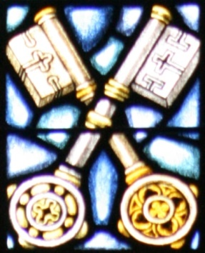 Catechesis is an education in the faith which includes especially the teaching of Christian doctrine imparted in an organic and systematic way. Our plan of teaching the faith is built on these four pillars as outlined in the Catechism of the Catholic Church:

THE FOUR PILLARS OF CATECHESIS

PART ONE: The baptismal profession of faith (the Creed) which summarizes the gifts that God gives to man: as the Author of all that is good; as Redeemer; and as Sanctifier – and develops our faith in the one God; the almighty Father, the Creator; his Son Jesus Christ, our Lord and Savior; and the Holy Spirit, the Sanctifier, in the One, Holy, Catholic and Apostolic Church.
PART TWO: The sacraments of faith which explains how God’s salvation, accomplished once for all through Christ Jesus and the Holy Spirit, is made present in the sacred actions of the Church’s liturgy, especially in the seven sacraments.
PART THREE: The life of faith (the Commandments) which deals with the final end of man created in the image of God: beatitude, and the ways of reaching it – through right conduct freely chosen, with the help of God’s law and grace, and through conduct that fulfills the twofold commandment of charity.
PART FOUR: The prayer of the believer (the Lord’s Prayer) deals with the meaning and importance of prayer in the life of believers.

  - Above all else, the aim of this catechesis and the whole concern of doctrine and its teaching are directed to the love that never ends – love of our Lord.

