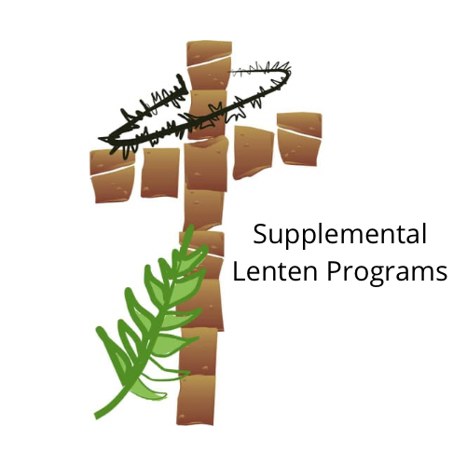
Best Lent Ever – Dynamic Catholic
Feed Your Soul with Prayer this Lent!
Nothing will transform your life so completely like really learning how to pray. This year’s BEST LENT EVER journeys through Matthew Kelly’s latest book, I Heard God Laugh: A Practical Guide to Life’s Essential Daily Habit.
Beginning on Ash Wednesday and continuing through all 40 days of Lent, you will receive a daily email with a short video to help you reconnect with yourself and your God. We promise you that you will be surprised by what God can do in your life with just an email, a short video and an open heart.
Sign up at https://dynamiccatholic.com/lent/best-lent-ever.html

Led by the Spirit: Daily Lenten Reflections with Dr. Tim Gray – Formed
40 Days to Grace and Glory
This Lent, embark on a journey with Dr. Tim Gray by signing up for Daily Lenten Reflections. Each day you will receive in your inbox a short video featuring Dr. Gray’s comments on the daily Mass readings, explaining the Scriptures, and providing you with concrete ideas on how to apply them to your life.
Formed · The Catholic Faith. On demand.

Hallow

Pray Every Day this Lent

Pray with millions around the world leading up to Easter alongside Mark Wahlberg, Jim Caviezel, Fr. Mike, and more on Hallow, the #1 prayer app in the world.
Hallow – The #1 Catholic Meditation, Prayer & Sleep App

Celebrate Lent using these resources!

Living the Faith

10 Things to Remember During Lent
10 Pointers for Prayer
A Good Friday Reflection
A Reflection on Lenten Fasting
Additional Ways to Pray
Almsgiving: Love in a Troubled World
Confession: Try it! You’ll like it!
Finding Hope in the Suffering
Lenten Resolutions for Married Couples, Inspired by Pope Francis
Letting Go to Follow Christ
Reflections on the Song of the Suffering Servant
Reconciled to Right Relationship, Called to Heal and Restore
Six Ways to Evangelize during Lent
To Fast – Or Not

