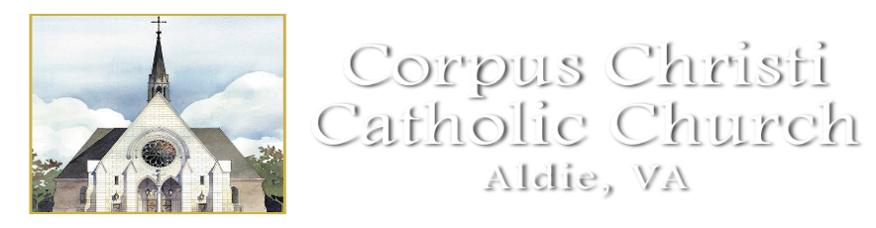
RELIGIOUS EDUCATION CLASS SCHEDULE 2023-2024
************************************************

September 11: Classes Begin
September 18: Class
September 25: Class

October 2: Class
October 9: No Class/Columbus Day Holiday
October 16: Class
October 23: Class
October 30: NO Class/LCPS Student Holiday

November 6: Class
November 13: Class
November 20: Class
November 27: Class

December 4: Class
December 11: Class
December 18: Class
December 25: No Class/Christmas Vacation
January 1: NO Class/SPVI CLOSED
January 8: Class
January 15: No Class/Martin Luther King Jr. Holiday
January 22: Class
January 29: Class

February 5: Class
February 12: Class
February 19: No Class/Presidents Day Holiday
February 26: Class

March 4: NO Class/LCPS Student Holiday
March 11: Class
March 18: Class
March 25: NO Class/LCPS Easter Break
April 1: No Class/SPVI Easter Break
April 8: Class
April 15: Class
April 22: Class
April: 29 Class

May 6: Last Day of Classes
May: 9 Confirmation
May 11: First Holy Communion

This calendar is the general 2023-2024 Religious Education class calendar and does not show important events like Parent Meetings, Retreats and Sacraments. This calendar is subject to change. For the current RE calendar please visit our website at www.corpuschristisr.org

