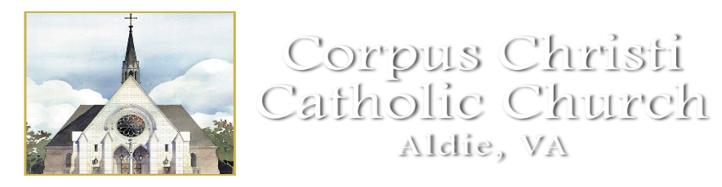
RELIGIOUS EDUCATION CLASS SCHEDULE 2022-2023
************************************************

September 12: Classes begin
September 19: Class
September 26: Class

October 3: Class
October 10: No Class/Columbus Day Holiday
October 17: Class
October 24: Class
October 31: No Class/Halloween

November 7: Class
November 14: Class
November 21: Class
November 28: Class

December 5: Class
December 12: Class
December 19: No Class/Christmas Vacation
December 26: No Class/Christmas Vacation
January 2: NO Class/SPVI CLOSED
January 9: Class
January 16: No Class/Martin Luther King Jr. Holiday
January 23: Class
January 30 Class

February 6: Class
February 13: Class
February 20: No Class/Presidents Day Holiday
February 27: Class

March 6: Class
March 13: Class
March 17: All classes at Church for Stations of the Cross/families included
March 20: Class
March 27: Class

April 3: No Class/LCPS Easter Vacation
April 10: No Class/Easter Vacation
April 17: Class
April 24: Class

May 1: Last Day of Classes
May 6: First Holy Communion
May 8: Confirmation

This calendar is the general 2022-2023 Religious Education class calendar and does not show important events like Parent Meetings, Retreats and Sacraments. This calendar is subject to change. For the current RE calendar please visit our website at www.corpuschristisr.org

