Feast Day Procession and Parish Picnic - June 11!
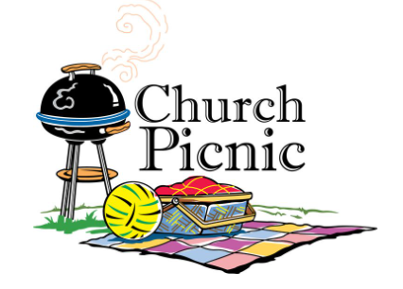
Sunday, June 11, we will celebrate the Feast Day of Corpus Christi with our 2nd Annual Eucharistic Procession following the 11:30 am Mass.

Following the procession events, we will be hosting a parish picnic from
12:30 PM to 3:30 PM

Enjoy Games, Face Painting, Arts & Crafts and more!

The Knights of Columbus will be grilling on site. You will be able to purchase:
- Hot dogs $1 each - with drink and chips
- Hamburgers $3 each - with drink & chips
For volunteer opportunities for you and your teens, email events@corpuschristisr.org

Bring beach chairs and blankets!!!!

Please RSVP by June 9th to: events@corpuschristisr.org
with number of attendees and food choices

