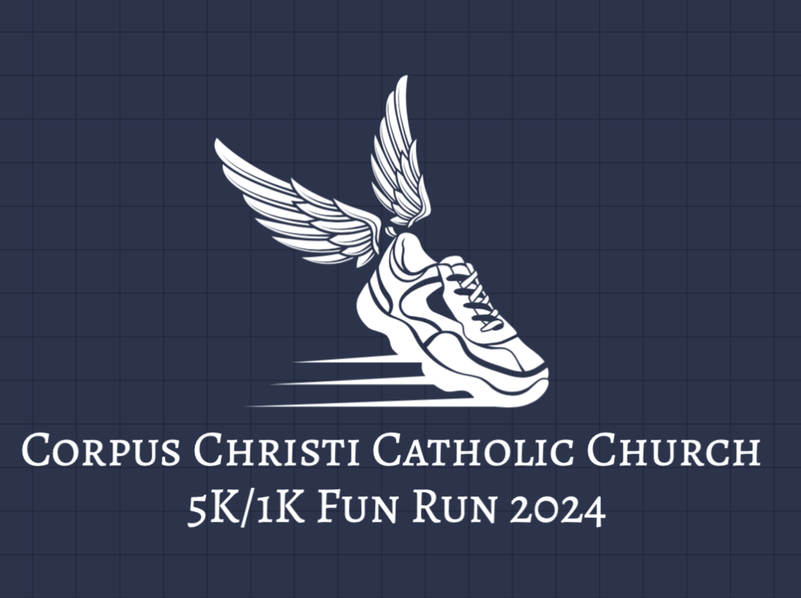

Join us Saturday, April 20, 2024, for our 5K/1K Fun Run!

Two race lengths, the option to walk or run, and the fresh outdoors makes this a great family friendly activity. This fundraising event is designed to support and strengthen our growing community.

Registration is open using the link below!
https://runsignup.com/Race/VA/Aldie/RaisetheRoofforCorpusChristiChurch5K1KRun

Sponsors needed! If you (or your company) would like the opportunity to sponsor this year’s Fun Run, please email Rebecca DiDona at rebecca.didona@mac.com.

