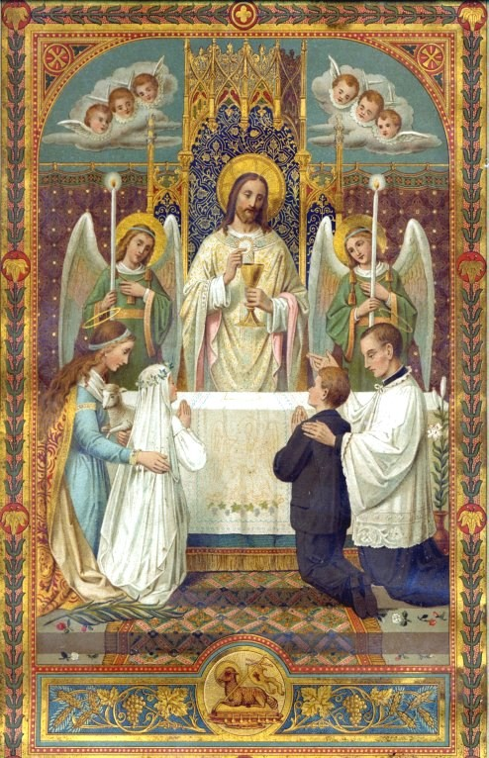
First Holy Communion
at
Corpus Christi Parish
2023

Religious Education Department Corpus Christi Catholic Church
41677 Corpus Christi Drive

Aldie, Virginia 20105
703-378-1037

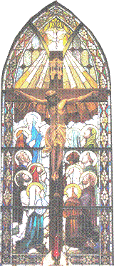

The First Penance/First Holy Communion Class
My Check List of First Holy Communion Requirements
Please notify your teacher to request assistance if you are having a problem in any of the areas below. This form is to help you organize your assignments and does not have to be handed in.
 | Requirement | 1. I attend Mass on Sundays and Holy days of Obligation. | 2. I am registered for the First Holy Communion Class. | 3. I have submitted a copy of the FHC registration form. | 4. I have submitted a copy of my baptismal certificate. | 5. I attend all classes regularly (at SPVI or at home.) | 6. I have studied and understand the Blessed First Holy Communion Program | 7. I can recite the following prayers: | The Sign of the Cross | The Our Father | The Hail Mary | The Glory Be | The Act of Contrition | 8. I can recite, or at least understand, the 10 Commandments | 9. I have received my First Penance. | 10. I have had my interview. Children attending CCD classes have their interview in class.
 | Check Here

Your child is preparing to receive the Sacraments of Penance and the Holy Eucharist. This handbook has been prepared by the Religious Education Department to help you understand our program at Corpus Christi Parish and hopefully it will help to answer any questions you might have. We share your excitement as we assist you during these important events in the life of your child.
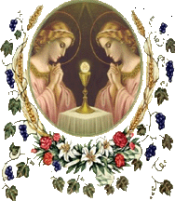

The First Penance/First Holy Com- munion Sacrament Class is a two-year program encompassing both.
first and second grade. You must register your child for these classes to receive these sacraments. Please be aware that your child must be seven years old to receive Holy Communion.

Not uncommonly, we have older children who need preparation for these sacraments. They are welcome either to join the second-grade class or, if the child is much older, to make special arrangements through the Reli- gious Education Office to join the Sacrament Preparation class. Please contact us and let us help you get your child caught up and back on track. We are always glad to help.

Required Parents’ Meetings (October 30, 2023)
To assist parents who have a child in the First Holy Communion class, there is a required Parents’ Meeting Meetings each year. At least one parent must attend the meeting. This informational meeting is for parents only and to facilitate the efficiency of the meeting we request that, when possible, all children be left at home. The meeting will take about one hour, and every effort will be made to keep each meeting on schedule. We understand that your time is valuable.

Baptismal Certificates
If you have not done so, you will be required to bring a copy of your child’s baptismal certificate to the parish office. If you do not have

Where to Get Additional Information

Each week you will find a Reli- gious Education column in the church bulletin. This will be the primary way for the Religious Education Department to com- municate information to parents. Please make sure you check this column each week. For those with internet access, please check out our parish website at: cor- puschristisr.org. Throughout the year, valuable information will be posted on the announcement page. Please do not hesitate to call or stop by the parish office during regular Religious Education hours.
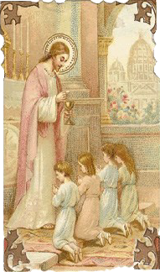

What Comes After Second
Grade?
Before you know it, your child will have received his or her First Penance and First Holy Communion but your job as parent does not end here. Nor is this the time to take a long break until your child is ready for Confirmation. You must provide for your child’s ongoing religious instruction and take your child to Mass and to the sacraments regularly. The answer to “What comes after second grade?” is Third Grade. We hope that each parent knows the answer to that question. Unless you are homeschooling or at- tending a Catholic school, we expect that each child will continue with Religious Education classes at Corpus Christi Parish. We have a solid Religious Education and youth program. Remember, there is a community aspect to our faith and Religious Education is an important part of this. Please stay with the program and al- low us to continue to assist you in the spiritual formation of your children as young Catholics.

a photocopy and you bring the original to the meeting we will be happy to assist you by making a copy for you. If you do not have a copy and your child was baptized at Corpus Christi Parish, please fill out the First Holy Communion Registration Form and the parish office will confirm the baptism information for those children baptized at Corpus Christi Parish. If you do not have one and your child was baptized at another church, you must contact that church to request one.

Church records are kept for each person at the church of that person’s Baptism. Unless your child was baptized here at Corpus Christi Parish, we do not have a copy of your child’s baptismal certificate. Providing us with a copy of your child’s baptismal certificate enables us to have the information we need to properly notify the church where your child was baptized that your child has received his or her First Holy Communion.

Official Church records are handwritten in a parish registry book and kept in a fireproof safe—there is no computer database to query and quickly pull up information.

Student Responsibilities
Students are expected to attend classes faithfully each week and to complete all homework assignments. Teachers are here to support and assist parents and are not expected to do the whole job themselves. Making sure your child completes homework assignments and practices their prayers are ways you can help your child’s teacher maximize valuable class time and, more importantly, it is an opportunity to share your faith with your child.

Students are expected to treat teachers, adults, peers with Christian Charity and Church / school property with respect. Our goals of teaching the Faith and inspiring love of God and neighbor call everyone to practice what is being taught.

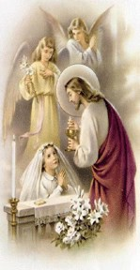First Penance
Girls—
- All First Holy Communion girls should wear a modest, white dress. The dress must be below the knee and have some sort of sleeve. Please, if the dress is sleeveless or has spaghetti straps, make sure your child wears a white cover-up jacket or sweater.
- A white head covering is required. This could include a First Holy Communion veil, chapel veil, or flower wreath. White barrettes with flowers and ribbons attached is also acceptable.
- White dress shoes and white socks, tights or stockings are re- quired.

Please shop early for all First Holy Communion items since parents have informed us that some items may be hard to find, please plan ahead.
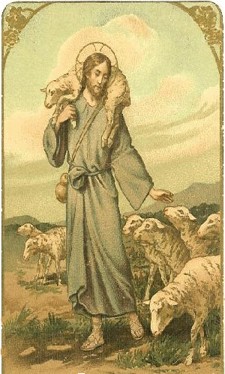Your child is being prepared for First Penance, but we cannot do this by ourselves. Your child’s teacher needs your help. Make sure your child knows an Act of Contrition and speak to him about the importance of this beautiful sacrament. Role play works well here, as being prepared helps re- duce any stress your child may have. The Examination of Con- science and Confession Guide booklet has been prepared by the Religious Education Department and children are welcome to take this aid into confession with them.

On the day of the First Penance, we ask the children to dress in their Sunday best, so the children will know this is a special day. Please plan to make sure to arrive on time. If people are still arriving after the start time, it will be disturbing for the children who will be in prayer.

We regret that, due to a time restraint, family members will not be able to go to confession at this time. However, parents are encouraged to take their child to confession prior to the First Holy Communion and this would be an excellent time for the whole family to go to confession together.
The FHC retreat will take place at the Church, on: February 10, 2024, 8:30-12.
First Penance will take place, at the Church, on: March 9, 2024, beginning at 9 am.
Practice will be held, at the Church, on My 2, 2024, at 6 pm
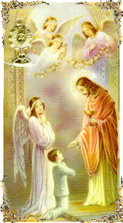
The First Holy Communion
First Holy Communion will be celebrated on Saturday, May 11, 2024, at 10 am at our Church, 41685 Corpus Christi Drive, Aldie, Va. 20105.

On the day of First Holy Communion, children should arrive at the Church no later than 9:30 am in proper attire, please be on time.

The children will process into their reserved seats prior to the beginning of Mass with their families. All First Holy Communion Candidates will sit on the aisle.

To respect this sacred occasion, photography and videography are not permitted during the Mass. Professional photos will be taken and made available to you.

You will be able to take pictures after the Mass.

When arriving to the Church prior to Mass, please be reverent. People will be praying in preparation of Mass, and we want to maintain reverence.

Dress Requirements
First Penance—Children should dress as they would for Sun- day Mass.
First Holy Communion—In order to keep the children fo-
cused on the Mass and on Jesus, the teachers have requested that the children not be allowed to carry anything with them—no purses, rosaries, or prayer books, etc.

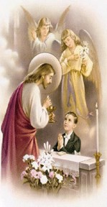

Boys—
- All First Holy Communion boys should wear a white shirt, a dark suit or dark dress pants and dark jacket (dark blue, gray, or black). Khaki pants and dark sport coats are permitted.
- A tie or bow tie is required.
- Dress shoes and dark socks are required.

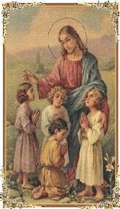What Parents Can Do to Help
Parents are the primary educators of their children. The Religious Education Department at Corpus Christi Parish works in partnership with parents to assist them in living their vocations as educators of their children. Our program is intended to complement, not replace, the catechesis children should receive in the home.
As we strive to inspire our students to practice their Faith in daily life and to form sound habits that will serve them for the rest of their lives, please remember that Catholics are obliged to attend Mass each Sunday (or Saturday vigil) and each Holy Day of Obligation. This is not optional. Your attendance at Sunday Mass, your frequent reception of the Holy Eucharist and frequent reception of the Sacrament of Penance will serve as an example for your children. Involvement in the parish is also encouraged to demonstrate to your child what is important in your life.
Assist your child in developing a real and loving relationship with Jesus. Pray each day with your child. Morning and nighttime prayers, grace be- fore and after meals and family rosary are suggested. Help your child learn to make a short examination of conscience each evening. Please place special emphasis on the Act of Contrition, making sure your child has this prayer memorized prior to First Penance. Help to increase your child’s desire for Jesus in the Holy Eucharist by teaching how to make a spiritual Communion and by visiting Our Lord in the Blessed Sacrament.
Tell your child about God’s great mercy. Your child will love to hear the stories of the Prodigal Son and the Lost Sheep repeatedly. Most importantly, make sure your child understands the difference between ordinary bread and the Body, Blood, Soul and Divinity of Jesus Christ in the Holy Eucharist.
If your child is in Religious Education classes, please review your child’s weekly lessons and make sure any assigned homework is completed. We cannot properly educate your child in the faith without your help. Your interest and assistance is vital. Please know that you are welcome to visit your child’s class at any time and you are encouraged to get to know your child’s teacher.

Absence/Tardiness
Attendance will be taken in each class. Students with more than three absences may be asked to show their knowledge in an interview with the
Director of Religious Education, or Father Taylor, before First Holy Communion. If your child must be absent due to illness, please send a note explaining the situation and your child will be given an excused absence. Please do not send a sick child to class.
Try to be on time for each class. Please do your best as the teachers will make every effort to start class on time.

The Interview
Those students who are not attending Religious Education classes at St. Paul VI Catholic High School, who will be making their First Holy Communion with us will be asked to demonstrate their knowledge of the subject matter in an interview with the Director of Religious Education. We have found in the past that our home school students are well catechized and neither parents nor student should be overly concerned about the interview. It will be a positive experience.

The knowledge your child will be asked to demonstrate will come from the Faith and Life Program. While it is impressive to see those students who truly have the cate-
chism answers memorized, it is only necessary that the child un- derstand the answers, not have them memorized.

As the time approaches for your child’s First Holy Communion, you will receive an email from the parish office to schedule the group interview.

Students who attend religious ed- ucation classes at St. Paul VI Catholic High School will not be given an interview as teachers test their students regularly.

