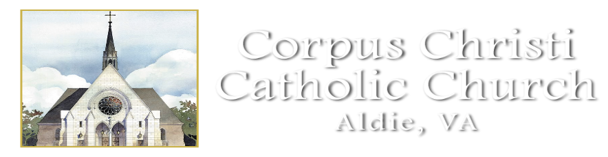
High School Calendar
All Classes will meet at the Parish Office from 5-6:30 pm
43130 Amberwood Plaza, Suite 150, South Riding, VA. 20152

September 18, 2022
October 2, 2022
October 16, 2022
November 13, 2022
November 20, 2022
December 4, 2022
December 11, 2022
January 8, 2023
January 23, 2023
February 5, 2023
February 26, 2023
March 12, 2023
March 19. 2023
April 16, 2023
April 23, 2023
May 7, 2023

